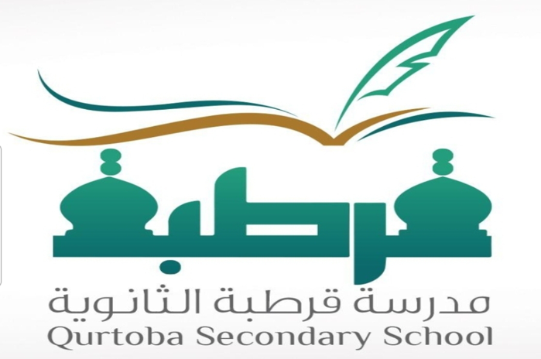
ْCordoba Secondary Makkah Region
Space Shuttle Al-Jamoum Governorate School

the introduction
In the name of God, the Most Gracious, the Most Merciful, in the name of God, the One and Only, in the name of God, the One and Only, the Eternal, Praise be to God, abundant praise, and blessings and peace be upon His Messenger.
Who chose.
As for what follows, today we will talk about the topic (the space shuttle), which occupies a lot of thought, and we hope to do it justice, as we hope.
The topic must have included all important and relevant aspects and no information has been omitted.
the topic
Enterprise (NASA designation: 101-OV
It had an autonomous engine or a thermal protection shield, so it was not designed for space travel, but rather for conducting tests related to take-off and landing.
And the modification was made to the basic design at that time, which was the shuttle Columbia and Challenger. Some of its parts were also used in re-tests
Representation of the Columbia shuttle disaster. With the completion of testing, it was returned to the Rockwell plant in Palmdale in October 1979 and was
To allow certain components to be reused on other shuttles.
The Space Shuttle Discovery (Discovery Shuttl Space) was one of the third orbital vehicles in operation in the fleet
NASA space shuttles. When it made its first flight in 1984, Discovery became...

Name: Abdulaziz Abdurhim Albishri
Activity leader: Nawaf Al-Barakati
School Director: Ayed Hamoud Al-Loqmani

